Transportation Cost Methodology

We must create an account in order to access the data. The link for the website is https://htaindex.cnt.org/

Sources of Data:

Transportation costs are obtained from the H+T index. The data in the H+T index is provided by Center for Neighborhood technology (CNT)

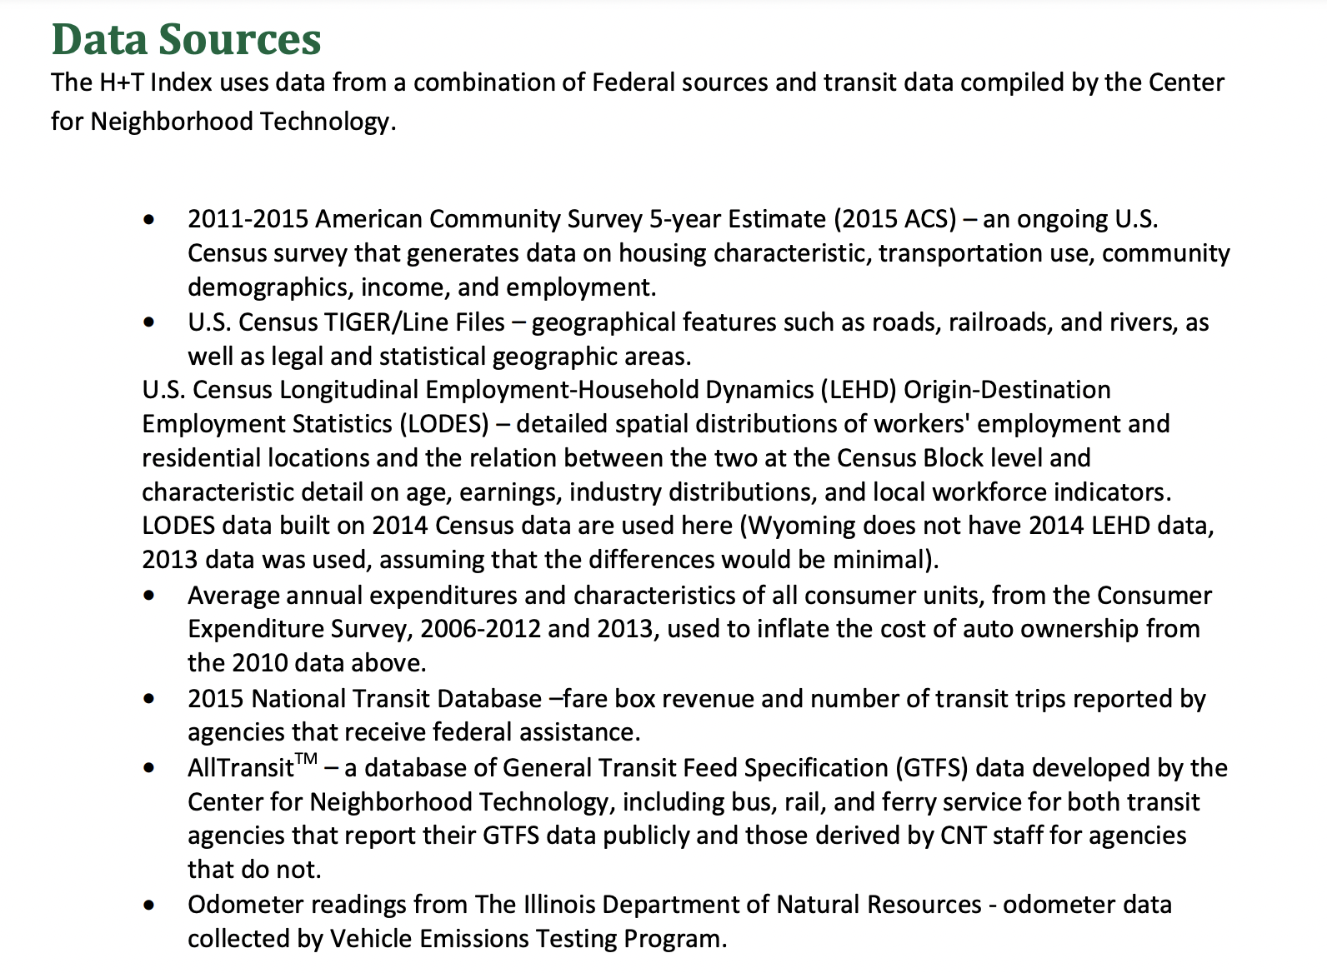

The Center for Neighborhood Technology’s Housing and Transportation (H+T®) Affordability Index provides a more comprehensive way of thinking about the true affordability of a place. It presents housing and transportation data as maps, charts and statistics covering 100% of the US population. Costs can be seen from the regional down to the neighborhood level.

The Index shows that transportation costs vary between and within regions depending on neighborhood characteristics:

- People who live in location-efficient neighborhoods—compact, mixed-use, and with convenient access to jobs, services, transit and amenities—tend to have lower transportation costs.
- People who live in location-inefficient places—less dense areas that require automobiles for most trips—are more likely to have higher transportation costs.

There are three main components involved in the Calculation of Transportation cost. They are

- Auto Ownership Cost
- Auto Usage
- Public Transit Usage

These three dependent variables are function of 14 independent variables

- Median household income
- Average household size
- Average commuters per household
- Gross household density
- Regional Household Intensity
- Fraction of rental housing units
- Fraction of single family detached housing
- Employment Access Index
- Employment Mix Index
- Block density
- Transit Connectivity Index
- Total Available Transit Trips per Week
- Transit Access Shed
- Jobs within the Transit Access Shed

Our implemented methodology accounting for families with various adults

- From the H+T index, we can get the Annual transportation cost for each census tract in a county

- They are given for a factor called household size which varies from county to county

- Our methodology is to divide the Annual transportation cost with corresponding household size so we will get transportation cost for a single adult

- When we divide that cost by 12, we can get the monthly transportation cost.

- One important Assumption is we assume that the transportation cost varies according to the number of adults in a family. This assumption is like Washington Self Sufficiency Standard

- So, from the monthly transportation cost, we have multiplication factors like 2,3 or 4 in order to account for families with multiple Adults.

- The Transportation cost is directly proportional to the number of adults in the family

- Transport_1 = Transportation cost for families with 1 Adult
- Transport_2 = Transportation cost for families with 2 Adults
- Transport_3 = Transportation cost for families with 3 Adults
- Transport_4 = Transportation cost for families with 4 Adults

